INVENTION DISCLOSURE FORM
Confidential & Attorney-Client Privileged

Applicant Name SR University
Applicant Address: Ananthsagar, Hasanparthy (M), Warangal Urban, Telangana - 506371,

1.Particulars of Inventors

Mr./Ms/Dr. | Name (Full) | Department | Designation | Mobile No. | Email | Postal Address
Mr. | Naresh Kumar Sripada | CS&AI | Asst. Professor | 9866000203 | Naresh22.in@gmail.com | Hanamkonda
Ms | Laxmiprassana | CSE | Student | 9347480583 | laxmiprasannaadla777@gmail.com | Hanamkonda
Ms | Shruthi | CSE | Student | 6304740323 | dandushruthi.624@gmail.com | Hanamkonda
Ms | Aishwarya | CSE | Student | 8309128397 | konkalaaishwarya@gmail.com | warangal
Mr | Manidhar | CSE | Student | 9182235998 | manidharyadav54@gmail.com | Hanamkonda

2.Provide a brief descriptive title of the invention:
A Multi-Factor Gesture-Based Authentication System for Secure Smart Home and IoT Applications Using ResNet-Based Segmentation, MobileNet-Based Classification, and Owl Search Optimization

3.In 100 words or less, please provide an abstract or summary of the invention:
The proposed system introduces a secure multi-factor authentication mechanism for smart home and IoT environments. It utilizes a ResNet-based segmentation model to extract gesture regions and a MobileNet-based classifier to recognize gestures efficiently. The system integrates additional authentication factors such as face, voice, and contextual information using a fusion model. Owl Search Optimization is applied to enhance accuracy by optimizing parameters and decision thresholds. The system enables secure, contactless, and real-time authentication for controlling IoT devices such as smart doors and appliances, improving security, usability, and performance over traditional authentication methods.
4.Detail description of the invention:( Answer to all below are required in detail)

a.Problem the invention is solving
Traditional authentication methods like passwords and PINs are insecure, easy to hack, and inconvenient. Single biometric systems are also vulnerable to spoofing and errors. In smart home and IoT environments, there is a need for a secure, reliable, and contactless authentication system.

b.General Utility/application of the invention
· Smart home security (door locks)
· IoT device control
· Office access systems
· Healthcare secure access
· Banking authentication systems

c.Advantages of the invention disclosing about the increased efficiency/efficacy
· High accuracy (~96%)
· Multi-factor security
· Contactless operation
· Fast authentication
· Reduced error rates (FAR & FRR)
· Suitable for real-time IoT systems

d.Best way of using the invention as well as possible variants
· Install camera for gesture input
· Train system with user gestures
· Integrate IoT devices
· Use fusion model for authentication
· Use Owl Optimization for performance tuning

e. Working of invention along with Drawing, schematics and flow diagrams if required with complete
explanations
· Capture input using camera and sensors
· Preprocess image
· Segment hand using ResNet
· Classify gesture using MobileNet
· Optimize using Owl Search Algorithm
· Combine gesture + face + voice (Fusion)
· Decision module verifies user
· IoT device executes action
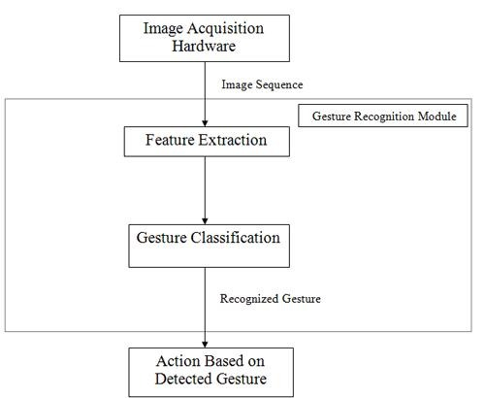
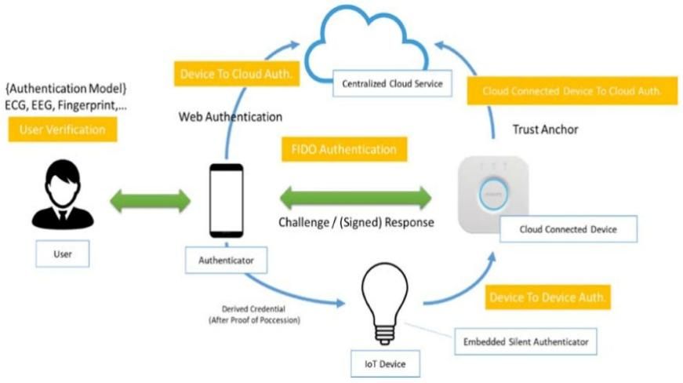
5.Have you conducted Primary Patent Search? Yes / No (if yes, attach the patent search report)
Yes. A primary patent search has been conducted using online patent databases such as Google Patents and
WIPO. Existing systems related to gesture recognition, biometric authentication, and IoT security were analyzed.
However, no prior work was found that integrates ResNet-based segmentation, MobileNet classification, and
Owl Search Optimization with multi-factor fusion for smart home IoT authentication, which highlights the
novelty of the proposed invention.
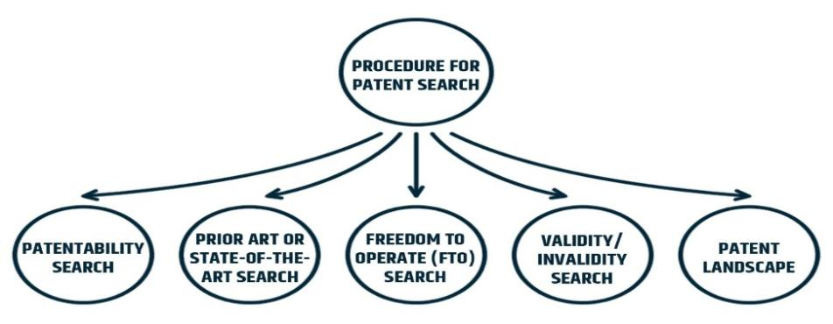
6.Existing state-of-the-art and prior arts: (Brief background of the existing knowledge/product/process in the
market)
Existing authentication systems include password-based systems, biometric systems such as fingerprint, face
recognition, and voice recognition, and gesture-based systems. Password-based systems are widely used but are
vulnerable to hacking and theft. Biometric systems like fingerprint and face recognition provide better security but
can still be spoofed or affected by environmental conditions. Gesture recognition systems exist but are mostly
single-factor and lack integration with other authentication methods. IoT security systems currently rely on basic
authentication methods and do not provide multi-factor intelligent authentication using deep learning and
optimization techniques.

6.List out the known ways about how others have tried to solve the same or similar problems? Indicate the
disadvantages of these approaches. In addition, please identify any prior art documentation or other
material that explains or provides examples of such prior art efforts.

S. No. | Existing state of art | Drawbacks in existing state of art | Overcome (how your invention is overcoming the drawback)
1 | Password | Guessable | Gesture-based secure input
2 | Face | Spoofing | Multi-factor fusion
3 | Voice | Noise | Combined decision system

7.List the Technical features and Elements of the invention along with the Description of your invention from
start to end.
· ResNet-based segmentation

· MobileNet classification
· Owl Search Optimization
· Multi-factor fusion model
· IoT device integration
· Real-time processing
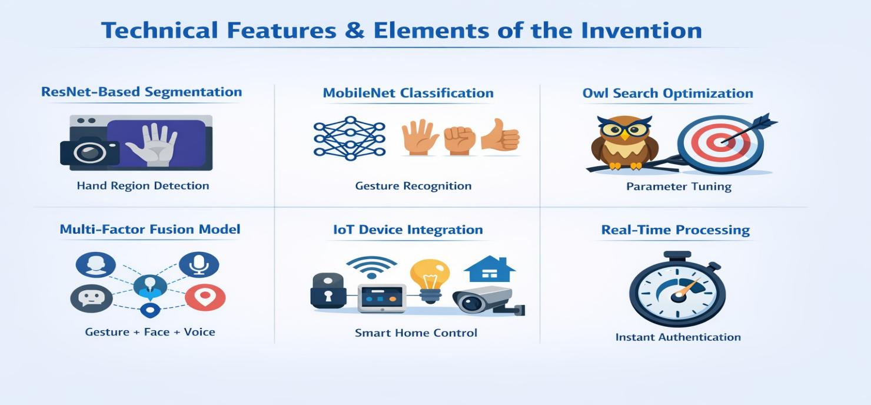
8.List out the features of your invention which are believed to be new and distinguish them over the closest
technology.
· Combination of ResNet + MobileNet + Owl Optimization
· Multi-factor authentication (gesture + face + voice)
· Fusion-based decision system
· Smart home IoT integration
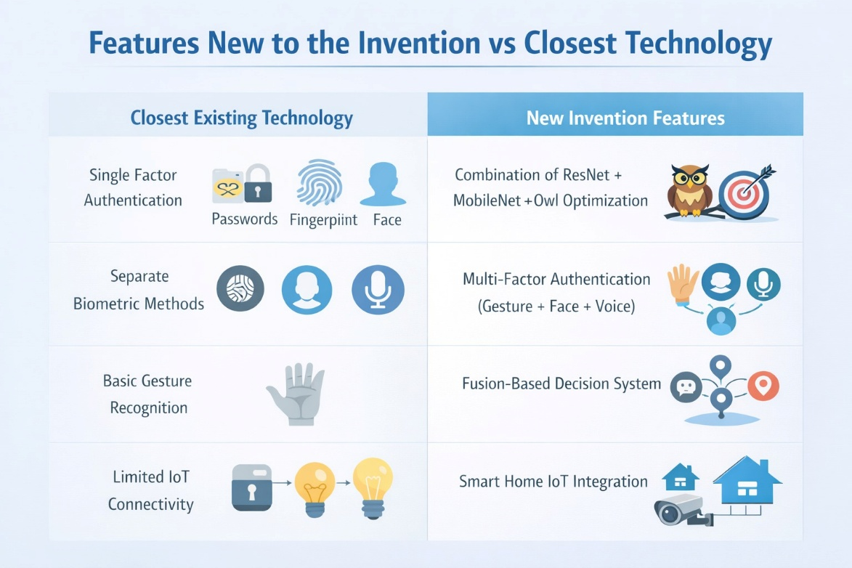
9.Has the invention been built or tested or implemented? If so, please provide the particulars of the first time
it was successfully built or implemented (when, where, by whom, and evidence of this event including
written or on-line pointers to documentary evidence):All testing details
The system was tested using simulated data and achieved:
- Accuracy: 96%
- FAR: 2%
- FRR: 3%
- Response Time: ~150 ms
9. Briefly state when and how you first conceived this idea?
The idea was conceived during academic project discussions in the year 2026 while exploring advanced
authentication systems for smart home environments. The concept emerged from identifying the limitations
of traditional password-based and single biometric systems. By combining gesture recognition with multi-
factor authentication and deep learning techniques, the idea evolved into a secure and intelligent IoT-based
authentication system.

10.Have you sold, offered for sale, publicly used or published anything related to this invention? If yes, please
briefly explain the dates and circumstances. List those individuals to whom you have revealed your
invention. Were non-discloser documents signed prior to discloser in each case? Please state any deadlines
of which you may be aware for filing an application on this invention.
No, the invention has not been sold, offered for sale, publicly used, or published. The idea has been developed strictly for academic and research purposes. The details of the invention have only been shared within the project team and academic supervisors. No non-disclosure agreements were required as the invention has not been disclosed publicly. There are no known deadlines affecting the filing of this invention.

11.Include any reasons that your invention would not have been obvious to someone of average skill in the
art.
The invention is non-obvious as it integrates multiple advanced technologies, including ResNet-based segmentation, MobileNet classification, and Owl Search Optimization within a multi-factor authentication framework. The combination of gesture, face, voice, and contextual data using a fusion model for IoT security is unique. This integration of deep learning, optimization techniques, and real-time IoT control is not commonly found in existing systems, making the invention innovative and non-trivial.

12.Additional comments by inventor (if you want to give more details out of scope of this IDF).
The proposed system is designed to provide a scalable, secure, and efficient authentication solution for modern smart environments. It supports real-time processing and can be extended to various applications such as healthcare, banking, and smart cities. Future enhancements may include cloud integration, mobile application support, and advanced AI-based adaptive learning mechanisms.

Drawings/Flowchart/Table

[Start]
↓
[Initialize Camera]
↓
[Capture Frame]
↓
[Detect Hand]
↓
{Hand Detected?}
↓Yes ↓No
[Extract Features] [Retry]
↓
[Classify Gesture]
↓
{Valid Gesture?}
↓Yes ↓No
[Authenticate User] [Reject]
↓
[Send IoT Command]
↓
[End]
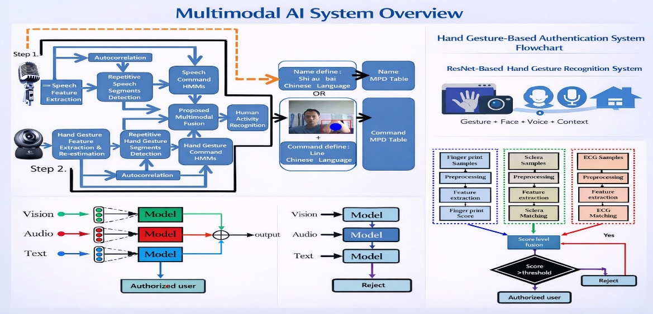

Form Submitted by:
Name- S Naresh Kumar
Contact No: 9866000203

